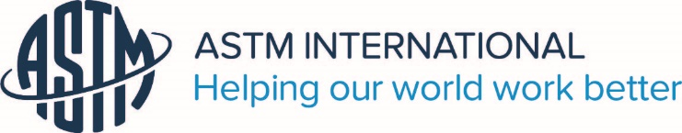

ASTM INTERNATIONAL
EMERGING PROFESSIONALS PROGRAM

Empowering Tomorrow’s Standards Leaders

ASTM technical committees are welcome to nominate a candidate who wants to become more active on their committee. https://www.astm.org/emergingprofessionals/

The objective of the Emerging Professionals program is to create a new opportunity with long-term benefits for new members who have demonstrated the potential to be industry and committee leaders.

Up to ten selected candidates per committee week will:
- Receive round-trip domestic economy airfare to and from the committee week up to $475USD
- Get two-night accommodations in the committee week hotel
- Attend an Emerging Professionals Workshop for a comprehensive introduction to ASTM and its standards development process
- Receive leadership development training from a professional facilitator and learn skills such as negotiation, consensus building, and problem solving
- Participate in technical committee meetings with a committee mentor

Criteria

Potential candidates for the program shall meet the following criteria:
- One to five years’ experience in standards development or in using ASTM standards in their work
- Works for a company, association, or government agency, that is currently using and/or developing ASTM standards OR attends a university (graduate level or higher) where their work involves/contributes to a significant ASTM activity
- Is available to attend the appropriate technical committee meeting
- ASTM International membership for at least one year is required for the candidate and mentor. Student membership is acceptable for the nominee

Workshop Dates 2019
June Committee Week, Denver, CO June 4, 2019 – nominations due 4/9/2019
June Committee Week, Denver, CO: June 25, 2019 – nominations due 4/16/2019
October Committee Week, Houston, TX: October 22, 2019 – nominations due 8/6/2019
November Committee Week, Houston, TX: November 5, 2019 – nominations due 8/13/2019

Workshop Speaker

McKinley Advisors in Washington, D.C. will be providing the guest speakers at the June, October and November workshops. McKinley has decades of experience and a steadfast commitment to advancing the work of mission-driven organizations.

*Supporting materials may be submitted electronically to Katerina Koperna at ASTM International: kkoperna@astm.org or mail to: 100 Barr Harbor Drive, West Conshohocken, PA 19428

